DevOps Tutorial : Introduction To DevOps

**The DevOps Tutorial**

In this DevOps Tutorial blog I will take you through the following things, which will be the base of the upcoming blogs:

* What led DevOps to come into existence
* Introduction of DevOps

**Waterfall Model**

Let’s consider developing software in a traditional way using a Waterfall Model.

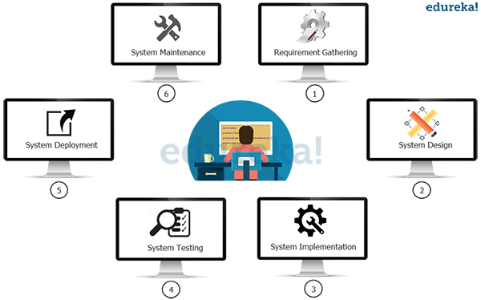

In the above diagram you will see the phases it will involve:

* ­In phase 1 – Complete Requirement is gathered and SRS is developed
* In phase 2 – This System is Planned and Designed using the SRS
* In phase 3 – Implementation of the System takes place
* In phase 4 – System is tested and its quality is assured
* In phase 5 – System is deployed to the end users
* In phase 6 – Regular Maintenance of the system is done

**Waterfall Model Challenges**

The Water-fall model worked fine and served well for many years however it had some challenges. In the following diagram the challenges of Waterfall Model are highlighted.

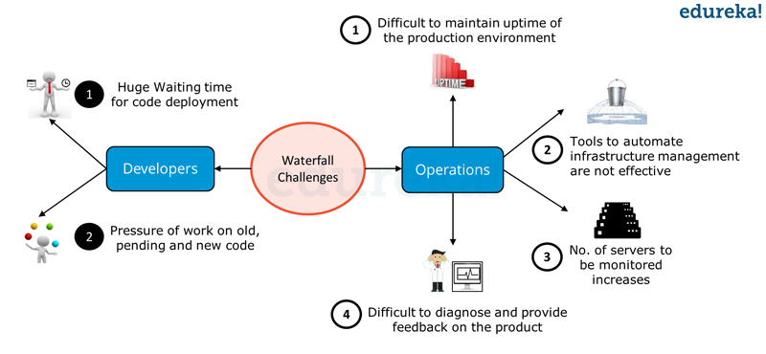

In the above diagram you can see that both Development and Operations had challenges in the Waterfall Model.  From Developers point of view there were majorly two challenges:

1After Development, the code deployment time was huge.

2Pressure of work on old, pending and new code was high because development and deployment time was high.

On the other hand, Operations was also not completely satisfied. There were four major challenges they faced as per the above diagram:

1It was difficult to maintain ~100% uptime of the production environment.

2Infrastructure Automation tools were not very affective.

3Number of severs to be monitored keeps on increasing with time and hence the complexity.

4It was very difficult to provide feedback and diagnose issue in the product.

In the following diagram proposed solution to the challenges of Waterfall Model are highlighted.

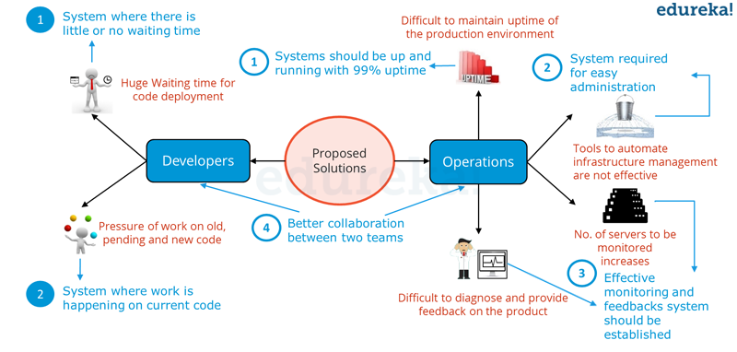

In the above diagram, Probable Solutions for the issues faced by Developers and Operations are highlighted in blue. This sets the guidelines for an Ideal Software Development strategy.

From Developers point of view:

1A system which enables code deployment without any delay or wait time.

2A system where work happens on the current code itself i.e. development sprints are short and well planned.

From Operations point of view:

1System should have at-least 99% uptime.

2Tools & systems are there in place for easy administration.

3Effective monitoring and feedbacks system should be there.

4Better Collaboration between Development & Operations and is common requirement for Developers and Operations team.

I guess it’s time we explore what is DevOps and how it overcomes these challenges. Check out the below video on What is DevOps before you go ahead.

**What is DevOps? | DevOps Training – DevOps Introduction & Tools | DevOps Tutorial | Edureka**

[Learn DevOps From Experts](https://goo.gl/RI3UiM?utm_source=blog&utm_medium=button&utm_campaign=blog-learn-devops-from-experts)

DevOps integrates developers and operations team to improve collaboration and productivity.

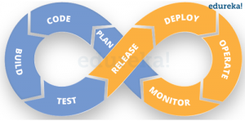

Devops Lifeycle – DevOps Tutorial – Edureka

According to the DevOps culture, a single group of Engineers (developers, system admins, QA’s. Testers etc turned into DevOps Engineers) has end to end responsibility of the Application (Software) right from gathering the requirement to development, to testing, to infrastructure deployment, to application deployment and finally monitoring & gathering feedback from the end users, then again implementing the changes.

This is a never ending cycle and the logo of DevOps makes perfect sense to me. Just look at the above diagram – What could have been a better symbol than infinity to symbolize DevOps?

Now let us see how DevOps takes care of the challenges faced by Development and Operations. Below table describes how DevOps addresses Dev Challenges.

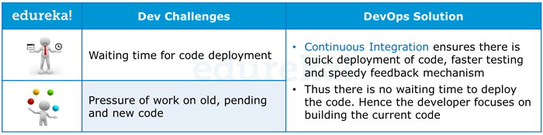

**DevOps Tutorial Table 1 – Above table states how DevOps solves Dev Challenges**

Going further, below table describes how DevOps addresses Ops Challenges.

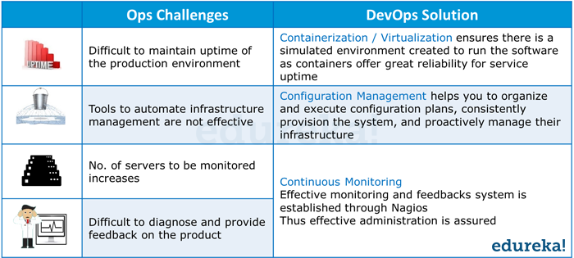

**DevOps Tutorial Table 2 – Above table states how DevOps solves Ops Challenges**

However, you would still be wondering, how to implement DevOps. To expedite and actualize DevOps process apart from culturally accepting it, one also needs various DevOps tools like Puppet, Jenkins, GIT, Chef, Docker, Selenium, AWS etc to achieve automation at various stages which helps in achieving Continuous Development, Continuous Integration, Continuous Testing, Continuous Deployment, Continuous Monitoring to deliver a quality software to the customer at a very fast pace.

[Learn DevOps Tools Now](https://goo.gl/rP5UrB?utm_source=blog&utm_medium=button&utm_campaign=blog-learn-devops-tools-now)

Now take a look at the below DevOps diagram with various DevOps Tools closely and try to decode it.

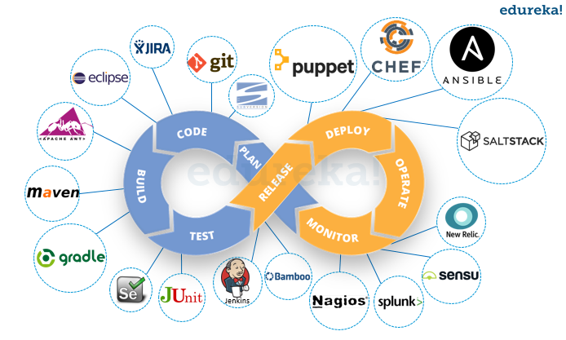

These tools has been categorized into various stages of DevOps. Hence it is important that I first tell you about DevOps stages and then talk more about DevOps Tools.

DevOps Lifecycle can be broadly broken down into the below DevOps Stages:

* Continuous Development
* Continuous Integration
* Continuous Testing
* Continuous Monitoring
* Virtualization and Containerization

These stages are the building blocks to achieve DevOps as a whole.

[View Upcoming DevOps Batches](https://goo.gl/WaJxov?utm_source=blog&utm_medium=button&utm_campaign=blog-view-upcoming-devops-batches)

This is the end of the first blog of – The DevOps Tutorial Series.

To know more on DevOps Stages, [**Click here to visit the second blog – What is DevOps and Its Stages ?**](https://goo.gl/5C3bRV)

*Now that you have understood what is DevOps, check out the [DevOps training](http://www.edureka.co/devops/?utm_source=blog&utm_medium=content-link&utm_campaign=devops-tutorial" \t "_blank) by Edureka, a trusted online learning company with a network of more than 250,000 satisfied learners spread across the globe. The Edureka DevOps Certification Training course helps learners gain expertise in various DevOps processes and tools such as Puppet, Jenkins, Nagios, Ansible, Chef, Saltstack and GIT for automating multiple steps in SDLC.*

*Got a question for us? Please mention it in the comments section and we will get back to you*